NETWORK MAPPING LAB - Point Form
1. LOCAL RECONNAISSANCE
Private IP Address:
- Ran command: ip a | grep inet
- Found: 192.168.150.218/24
Gateway IP Address:
- Ran command: ip route | grep default
- Found: 192.168.150.204
Public IP Address:
- Ran command: curl ifconfig.me
- Found: 102.244.155.90
IP Class Determination:
- Local network uses 192.168.x.x
- This is Class C (private range 192.168.0.0 - 192.168.255.255)

DNS Lookup for google.com:
- Ran command: nslookup google.com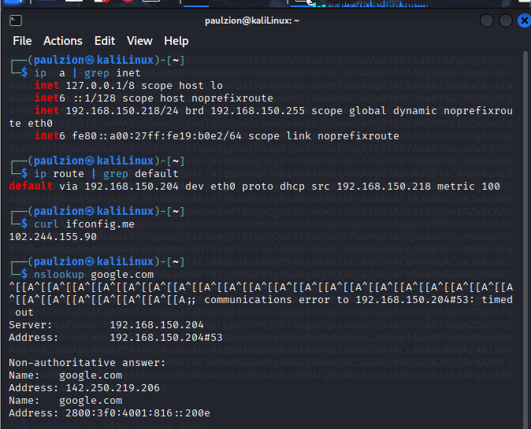
- Found IP: 142.250.219.206
2. COMMUNICATION ANALYSIS
Traceroute to 8.8.8.8
- Ran command: traceroute 8.8.8.8
- Results showed:

Test to 8.8.8.8:
- Ran command: ping -c 4 8.8.8.8
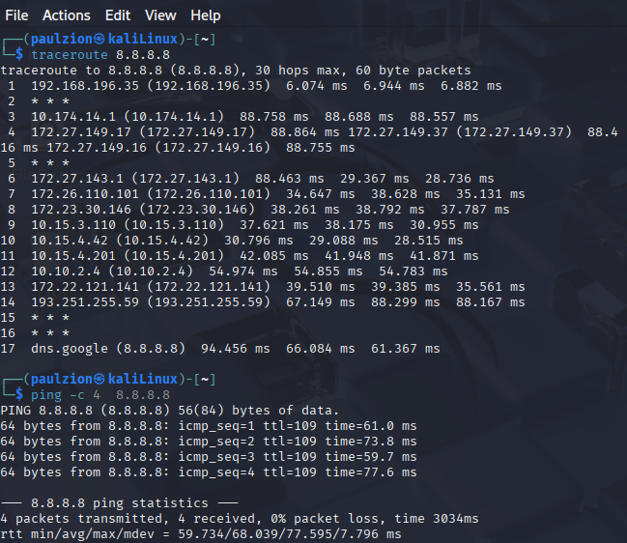

3. SECURITY PREPARATION
SSH Key Generation:
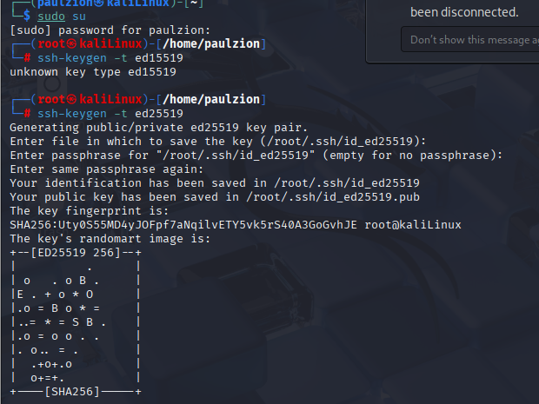
4. NETWORK MAP
INTERNET (Public IP: 102.244.155.90) → GATEWAY (192.168.150.204) → LOCAL NETWORK (192.168.150.0/24) → MY MACHINE (192.168.150.218) → EXTERNAL DESTINATIONS (8.8.8.8, 142.250.219.206, 93.184.216.34)

